Name:__________________________________________
Wastewater Treatment Activity

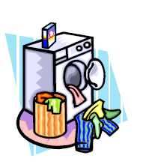
Table of Contents:
(1.) Wastewater Treatment Basics
(2.) Activity: Wastewater Treatment Plant Virtual Tour

Background
When you think about the variety of materials that enter the wastewater system from a typical home, the list is diverse and extensive: wastes from toilets; soap, detergents, and cleaning products from drains and washing machines; food items from garbage disposals - all along with large quantities of water. How is this material removed so that the water may be safely returned to the environment and, possibly, utilized again by other people downstream? The answer depends on where you live. If your home is not serviced by a public sewer system, your wastes are undoubtedly treated with a septic system. In this system, wastes are shuttled from the home into an underground storage tank. Sludge in the wastewater sinks to the bottom of the tank, oils float, and the water in between the two layers is dispersed into the surrounding soil through a network of pipes. The tank must be emptied on a regular basis, and the system properly maintained to ensure proper operation over time.

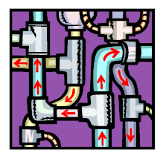
If your home is serviced by a public sewer system, the process is roughly the same but on a larger scale. Wastewater leaves your residence and is piped to a wastewater treatment facility, where it is run through a series of steps to clean the water prior to release into a creek, river, lake, or ocean. The first steps are collectively known as preliminary treatment, in which large objects are removed from the water stream with screens and large particles settle out as the flow rate of the water is reduced. In primary treatment, the wastewater is funneled into large holding tanks (sedimentation tanks) and left undisturbed to allow heavy particles to sink out, and greases and oils to rise to the surface. The material on the top and bottom of the tanks is skimmed away, and the water proceeds on to secondary treatment. In this stage, bacteria are introduced and they begin consuming the small particles of organic matter that remain in the water. To facilitate this, oxygen is pumped into the water to allow the bacteria to feed continuously, as low oxygen levels cause feeding rates to slow. The water then flows into another set of settling tanks, where most of the bacteria settle out and are pumped back into the aeration tanks. The water is then chlorinated or exposed to ultraviolet light to kill any remaining bacteria. On average, this process removes over 90% of the impurities that were in the water as it entered the plant.

- Based on the reading above, if your home is not serviced by a public sewer system, how are the wastes treated? Describe the system.

- If your home is serviced by a public sewer system please explain what happens to the water once it leaves your residence.
The material below describes the processes of wastewater treatment and septic tank operation in detail, and provides graphics to aid in understanding. Review this material before proceeding to the virtual tours.
Visit: http://www.metrocouncil.org/environment/Kids/01.htm

Note: if it does not move when you click go forward, click the number 2 above the diagram

- What color is the pipe containing “dirty water”?_______________
- What color is the pipe that takes water into the house?_______________
- What happens in preliminary treatment:

- What happens to large objects found in the water?

- What is a grit chamber and how is it used?

- Primary treatment removes _____________% of the pollutants in waste water.

- What happens to floatable solids such as grease and oil?

- What do you see coming from the smoke stack?

- What happens to the sludge in primary treatment?

- What happens in secondary treatment?

- What are some examples of microorganisms used in secondary treatment?

- What happens to the remaining dirt?

- What happens to the reaming water? (discuss the function of chlorine in your answer)

- What is the final process of wastewater treatment?

Click on “Another look at WWT” http://www.metrocouncil.org/environment/Kids/30.htm
- Summarize the process of waste water treatment based on the diagram above

Go to the next website: http://www.epa.gov/npdes/pubs/centralized_brochure.pdf

- Summarize the steps in wastewater treatment 101

- Summarize what they suggest in “flush responsibly”

- On page two – what items should not go down the drain?

- Where does the water go after you flush the toilet or drain the sinks at home?

Click on: http://www.epa.gov/npdes/pubs/what_happens_after_the_flush.pdf
- Examine figure A – Describe a septic tank and how it works. (also look at the information on septic tanks on pages 2-3)

- Up until the mid 1800s what was the normal practice in dealing with waste?

- Examine figure B – How long does water spend in the waste water treatment plant? _________________

- Where is water released when it is finished being treated?

- How many pounds of solids/sludge are produced annually per household?_______________

Click on Blue Plains Virtual Tour: http://esa21.kennesaw.edu/activities/ww-treatment/ww-tour-dc/blue_plains.swf
Activity: Wastewater Treatment Plant Virtual Tours
To truly appreciate the process of wastewater treatment and the magnitude of the job, one must visit a wastewater treatment plant in person. Seeing the processes firsthand is ideal but not always logistically practical, so we have provided an interactive, engaging “virtual tour” of a wastewater treatment facility for your use. In the Blue Plains Tour, you control the direction of the tour by selecting steps using the aerial view of the plant. Follow the numbered steps, clicking on the thumbnail images to enlarge and reading the associated text as you progress.

Interactive tour of Advanced Wastewater Treatment Plant in Washington, DC
District of Columbia Water and Sewer Authority http://www.dcwasa.com/about/tour_flash.cfm

Wastewater Treatment: Sequence of Events: Based on the background material and provided virtual tour, place numbers next to each of the steps in the wastewater treatment process listed below to show the order in which they occur.

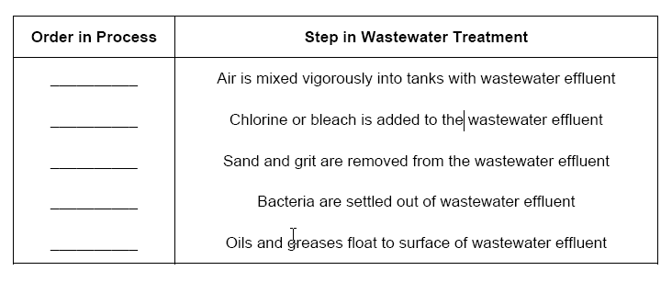
- Anything you flush down the toilet will eventually show up at the wastewater treatment plant (albeit not always in its original condition). Let’s say, for example, you accidentally drop a small towel down the toilet and it makes its way through the plumbing to the wastewater treatment plant. What device is likely to catch the towel at the plant, and what would be its ultimate destination if this occurred at the profiled treatment plant?

- Why is the wastewater effluent treated with chlorine, bleach, or ultraviolet light after secondary treatment?

- Describe how the organic solids collected in the wastewater treatment plant are processed after collection, and list their final destinations at the profiled plant.

- Eutrophication occurs when bodies of water, usually lakes or rivers, experience algal blooms from large inputs of plant nutrients like nitrogen and phosphorus, which leads to low oxygen levels in the water and adverse impacts on aquatic organisms. Both nitrogen and phosphorus can occur in large concentrations in wastewater effluent. Describe, in detail, the approaches taken at the profiled treatment plant to deal with nitrogen and phosphorus removal prior to the release of the effluent into the environment.

- Explain why the profiled plant should be particularly concerned about eutrophication given its release site.

